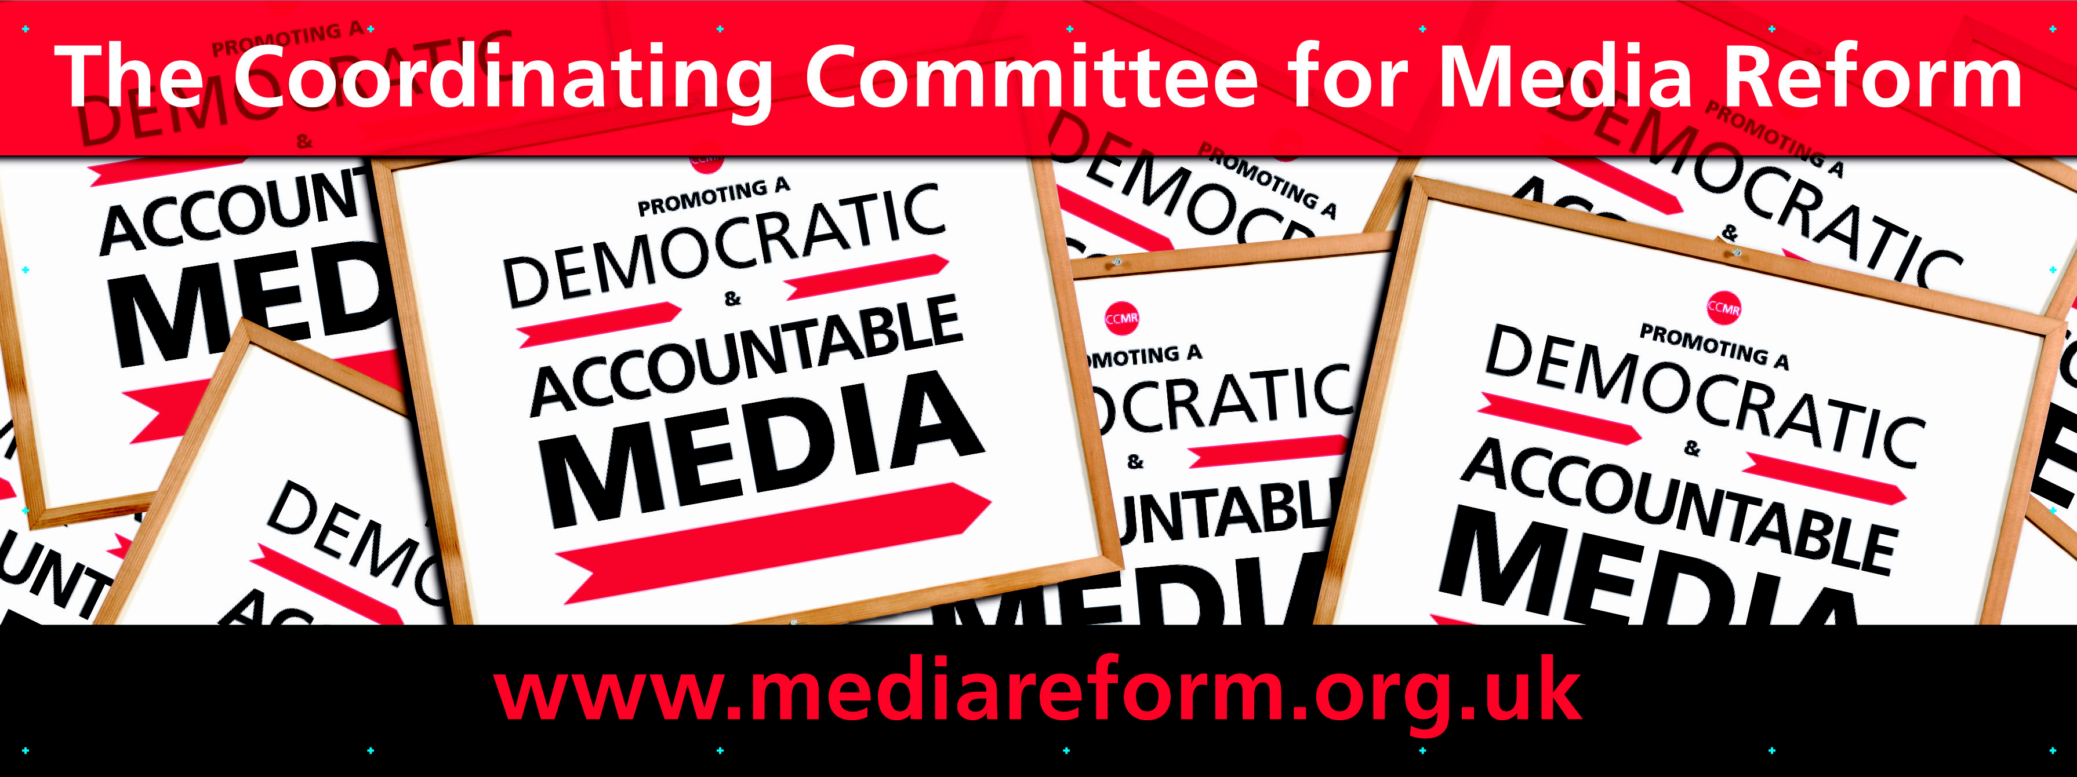

Seminar Series
(in association with Hacked Off)
MEDIA, POWER AND THE PUBLIC

6pm Wednesday 13 June

‘What Kind of Power? Media Reform and the Spectre of Democracy’
Dan Hind (author of The Return of the Public)

‘Renewing the Public Interest’
Professor Natalie Fenton (Goldsmiths, University of London and editor of New Media, Old News: Journalism and Democracy in the Digital Age)

6pm Tuesday 26 June

‘Can the Media be Co-operative?’, Dave Boyle (Co-operatives UK and author of Good News: A co-operative solution to the media crisis)

All meetings are free and open to all and take place at the Centre for Creative Collaboration, 16 Acton Street, Kings Cross, London WC1X 9NG (5 mins walk from Kings Cross station)

