

The Leveson Report: Recommendations for Media Plurality

The Leveson Report has called for the development of a new system for both measuring and tackling media concentration of ownership (pp. 1461-1476). It is a tacit acknowledgement that the existing regime has been inadequate in curbing ongoing concentration. This briefing identifies the key principles endorsed by Lord Justice Leveson’s recommendations on plurality in light of proposals put forward to the Inquiry by the Media Reform Coalition.
Unchecked media concentration over several decades has allowed some media groups to accumulate vast amounts of revenue and influence with adverse consequences for ethical journalism and democracy. One such consequence has been the development of intimate relationships between political and media elites in a way which, according to Lord Justice Leveson, “has not been in the public interest” (p.1956).
Leveson’s recommendations, while avoiding explicit proposals for new media ownership rules, nevertheless highlight three key principles:
- A new method is needed for measuring plurality, focussing on the provision of news and current affairs and including online publications.
One of the historical stumbling blocks in media ownership regulation has been the inherent difficulties in measuring media plurality. What is needed is an approach which takes account of both the enduring agenda setting power of dominant news outlets within traditional media markets, as well as the growing significance of cross-media concentration in an increasingly converged media environment. With regard to the former, the Media Reform Coalition has established a clear framework for measuring and identifying excessive market power in four designated sectors - national newspapers, television, radio and online news.
Each of these sectors requires a tailored metric appropriate to the nature of the medium and market. Whilst this is fairly clear in respect of national newspapers, television and radio (based on the regular industry surveys of ABC, BARB and RAJAR respectively) it is less clear in respect of the internet where no established industry metric currently exists and the market is global. However, research in 2011 by UKOM/Nielson was conducted specifically on the reach of UK news websites within the UK. The data was based on a survey of 50,000 people accessing the internet from office and work computers across the country and provided a useful measure of audience concentration within the national online news market. Such a survey could be commissioned by Ofcom on a regular basis in order to provide comparable data as follows:
- National newspaper circulation
- Multichannel television audience ratings
- Radio listening shares*
- Audience shares of UK-based news websites
(*Where radio news services are outsourced, market share is attributed to news provider rather than station).
When it comes to measuring cross-media power we clearly need a single, one size fits all approach. To this end, we support proposals put forward by Enders Analysis to base the measure on a share of total cross-media revenues. This is the simplest and most effective indicator of overall dominance.
- Triggers for intervention should be “considerably lower” (p. 1470) than those appropriate to ordinary competition concerns and should address organic growth within media markets as well as specific mergers and acquisitions.
Our approach is based on the principle that concerns over media concentration ought to be about the ‘share of voice’ commanded by a single company or group of companies, rather than just significant market power defined in purely economic terms.
But in order to identify what Leveson refers to as “levels of influence that would give rise to concerns in relation to plurality” (p. 1470), we need to establish clear ownership thresholds. We believe this is the only means by which plurality can be maintained in a consistent, fair and effective way. It is particularly important if remedies are to address concentration as a result of organic growth as well as merger activity. To shy away from establishing ownership thresholds is to place unnecessary powers of discretion in the hands of regulators and ministers.
Lord Justice Leveson has recommended that discretionary power remain with the Secretary of State in respect of public interest decisions over media mergers (p. 1476). But this is in conflict with much of the evidence and testimony submitted to his Inquiry. Evidence of a tacit ‘deal’ between political leaders and media industry lobbyists may never be substantive but we did learn a great deal about the pervasive nature and influence of industry lobbying. This was particularly evident in the run up to key decisions by the Secrety of State such as Jeremy Hunt’s approval of Newscorp’s bid to buy out BSkyB, prior to the unfolding of the phone hacking scandal. In this respect, it is worth noting the written testimony submitted by Tony Blair:
The media are obviously going to be a powerful part of society and in particular a power influence on political debate […] This challenge is further complicated in respect of any individual political leader, by the fact that our views about particular media organisations are bound to be affected by how we are treated by them.
In the absence of clear ownership thresholds, established in law, the door will always be open to both commercial capture (politicians may be induced to take certain decisions under pressure from media groups) and/or politicization (certain media groups may be unduly favoured or disadvantaged by political decisions).
Of course, any identified threshold will be to some extent arbitrary. But the Media Reform Coalition formally proposed to the Leveson Inquiry a 15 per cent benchmark that would trigger regulatory intervention (as described below) with a 20 per cent overall limit in key sub-markets. We argue this on the basis that no less than five owners—within or across media markets—is the minimum basis for media plurality. We are, therefore, surprised to read in the Leveson Report that “there have been no suggestions as to what level of plurality is sufficient” (p. 1469).
Based on recent market data available from Ofcom among other sources, the chart below illustrates the existing shares of dominant news providers across the aforementioned sectors.
Figure 1. Audience share of dominant news providers
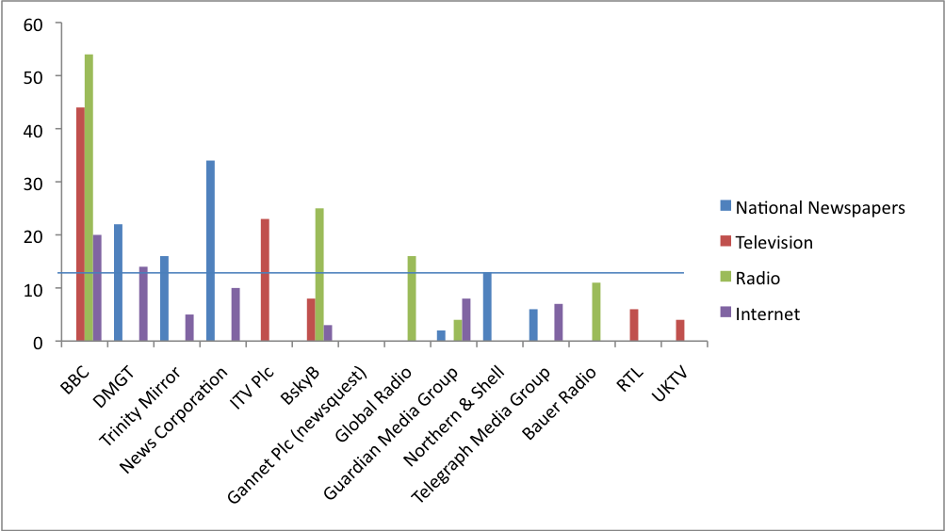
Excluding public service broadcasters, which are already subject to public duties, the following providers would be subject to intervention based on a 15 percent threshold:
National Newspapers | Television | Radio | Internet
News Corporation (The Sun, Sun on Sunday, The Times, Sunday Times) |  | Global Radio
Trinity Mirror (The People, The Sunday Mirror, The Sunday Mail) |  | BskyB (Sky News Radio)
DMGT (Daily Mail, Mail on Sunday)

A crucial area excluded from this measurement is local news. Although our overall proposals are designed to revitalise this sector via a Public Media Trust, Ofcom should have powers to intervene on public interest issues at the local level. Given the added complexities in measuring local news concentration, a problem that is acknowledged by Lord Justice Leveson (p. 1469), intervention should be triggered by public concern via the Sustainable Communities Act which is uniquely fit for this purpose.
- A new system should accommodate a range of remedies and forms of intervention.
The final question to address is in what form remedies or interventions should take. Our proposals stipulate that media groups with a dominant audience share within markets of between 15 and 20 per cent, based on the aforementioned indicators, should be subject to a new set of public interest obligations to ensure editorial and journalist autonomy, as well as a commitment to supporting those sectors of journalism (investigative and local) currently being squeezed out of the market. These obligations are akin to behavioural remedies which have strong and growing precedent under current anti-trust regimes adopted in both the EU and US.
It should be emphasised that what we are proposing falls well short of imposing editorial standards along the lines of public service regulation. But no single entity should be allowed to dominate public conversation without appropriate obligations that promote both a degree of internal pluralism, and a commitment to providing public interest news. It is these underlying plurality issues which our proposals for public interest obligations are chiefly concerned with.
An example of a public interest obligation in this context would be an undertaking to protect editorial autonomy. One of the chief concerns emerging from the hacking scandal is the extent to which both the autonomy and integrity of journalists can be compromised by a chain of command and institutional culture fostered by senior management. One way of addressing this issue is to introduce institutional arrangements that limit the absolute prerogative power of proprietors and senior management. As a minimum requirement, this should ensure that qualifying news organisations set up an editorial panel, including a minimum of five staff journalists, which is empowered to oversee key decisions affecting editorial policy as follows:
- The appointment and dismissal of the editor-in-chief, or equivalent, by management or proprietors must be approved by the editorial panel on the basis of majority vote.
- The panel must be consulted on decisions taken by management or proprietors which affect the definition or direction of editorial policy and content, including editorial codes and guidelines.
- The panel must have the ability to pass a motion of no confidence in an editor-in-chief, or equivalent, by majority vote.
- The panel must have the capacity both to hear and air grievances of staff journalists in relation to particular assignments, and to consult the National Union of Journalists or the new independent regulator.
Commercial press groups enjoy a significant public subsidy through VAT exemption so, in addition to the above, it is entirely appropriate that they make a financial commitment to support fledgling sectors of public interest journalism. This could be done in a variety of ways, including a levy on profits to support non-profit news initiatives (such as community radio and foundation-supported models of investigative journalism), or by imposing a commitment on qualifying entities to meet minimal levels of investment in original newsgathering.
In tandem with these behavioural remedies, we have also proposed a structural remedy to be triggered by a system of cross-media and sub-market thresholds. But each type of threshold warrants a distinct form of structural intervention. The objective of forced divestiture is usually to create a new viable competitor, or to strengthen the position of existing competitors through the break-up of a company’s assets. In the case of the media, this might be feasible and sensible when a company has acquired a number of assets across sectors such that it commands a dominant share of cross-media market revenues. To this end, we support proposals put forward by Enders Analysis which would prohibit any single company from commanding more than 15 percent of core media industry revenues.
But this will not solve the problem of concentrated power within particular media markets and we recognise that monopoly control policies based on divestment can raise difficulties when applied to these cases. We are therefore proposing a different structural remedy to be applied in these cases based on equity carve-out. Where a single outlet or group of outlets breach a given threshold of 20 per cent, this would entail the creation of a new company out of the subsidiary and the selling of shares accordingly. Whilst this might not lead to the creation of a new viable competitor, it could ensure that no single entity or individual has a controlling interest in the title or group of titles.
The particular advantage of this approach is that it is aimed specifically at limiting the influence of powerful interests. That is, after all, the primary concern attached to media plurality and is precisely the kind of intervention that is most needed - especially in the UK where individual proprietors are still dominant in the newspaper industry (in contrast to the US and much of western Europe). Furthermore, a remedy based on equity carve out will not deter growth or interfere with consumer sovereignty within media markets; and it can be implemented relatively easily based on Ofcom’s existing criteria for measuring controlling interests. We also believe that it will meet Ofcom’s objections to market caps—that they are a disincentive to innovation and are unduly inflexible—that were noted by Lord Justice Leveson in the Report (p. 1468).
Recent examples of shareholder activism in many industries, including shareholder pressure at News International for Rupert Murdoch to stand down, demonstrate that there is a growing appetite to exert influence on large companies on the basis of shareholdings. This trend indicates that equity carve out could genuinely increase internal plurality, as civil society groups and socially-oriented investors (such as pension funds) may well take up the opportunity to buy released shares in order to hold media companies to account.
In conclusion, we believe that his kind of remedy would work very effectively with our proposed public interest obligations. We have argued that public interest obligations should be applied to any media group that commands more than 15 percent share of a given audience and that no individual interest should control more than 20 percent of the markets for national newspapers, television, radio and online news. This will help to give us the plurality our democracy so desperately needs.

All our policies and further information can be found at www.mediareform.org.uk

